EXECUTIVE SPACE COURSE
SPACECRAFT DESIGN COURSE
Delta Preliminary Design Review (Delta-PDR)
A Systems Engineering Approach
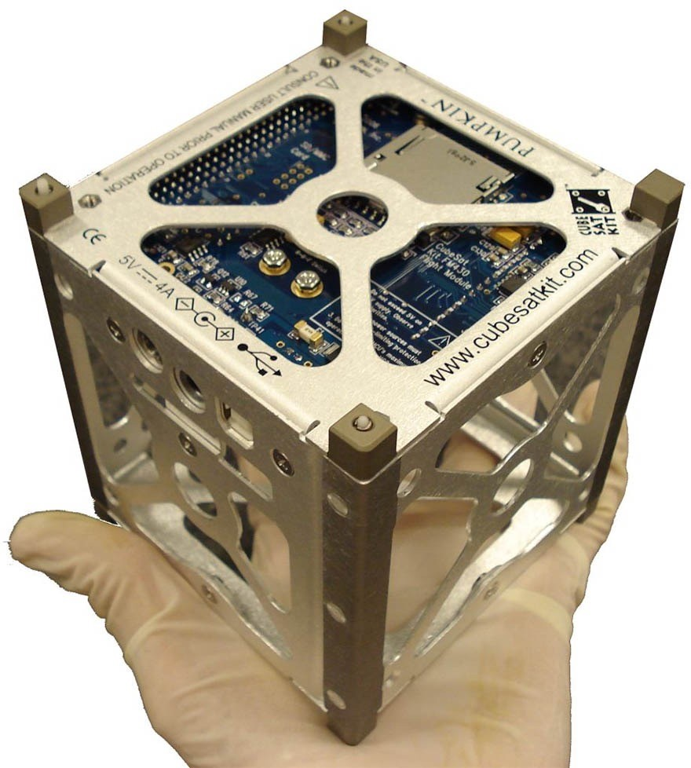
Date: 13/10/2026 to 16/10/2026

Groups
Participants will work in eight teams. Enter the participant names for each group and nominate one Project Manager per group.
Group 1 | Group 2 | Group 3 | Group 4

Group 5 | Group 6 | Group 7 | Group 8

Project Managers
A. Group 1: [Add name]
B. Group 2: [Add name]
C. Group 3: [Add name]
D. Group 4: [Add name]
E. Group 5: [Add name]
F. Group 6: [Add name]
G. Group 7: [Add name]
H. Group 8: [Add name]

Schedule
Date | Time | Activity
15 October 2026 | 10:45–11:00 | Mission concept
15 October 2026 | 11:30–12:00 and 13:00–13:45 | Mission concept
15 October 2026 | 15:15–17:00 | AIT phases
16 October 2026 | 10:15–11:15 | AIT phases
16 October 2026 | 12:00–12:45 | AIT phases
16 October 2026 | 13:45–14:45 | AIT phases
16 October 2026 | 14:45–16:00 | Delta-PDR presentations

Project Manager Responsibilities
- Plan the work, maintain the schedule, and track progress against agreed milestones.
- Understand the overall mission and coordinate tasks across the team.
- Allocate responsibilities and manage available human and material resources.
- Act as the main point of contact with the instructor and coordinate technical consultations.
- Monitor deliverables, risks, dependencies, and deadlines.
- Coordinate the final presentation, technical report, and supporting documentation.

Delta-PDR

Overview
The Delta-PDR is a structured review of each team's CubeSat mission concept and preliminary design. Teams apply a systems-engineering approach to define mission needs and requirements, develop a system architecture, justify key design choices, analyse budgets and risks, and plan assembly, integration and testing (AIT). The practical activities culminate in a demonstration of the 2NDSpace CubeSat kit and its end-to-end operation with a ground station.
The exercise introduces the key activities of a satellite-development lifecycle through the 2NDSpace CubeSat kit. Results from ground-based kit tests demonstrate only the functions tested under the stated conditions; they do not, by themselves, establish flight qualification or authorisation for launch.

Delta-PDR Objectives
- Define the mission concept, stakeholders, mission objectives, requirements, constraints, and concept of operations (ConOps).
- Develop and justify the CubeSat system architecture, subsystem interfaces, and major design trade-offs.
- Estimate and document mass, power, data, and communication-link budgets.
- Select and justify a suitable orbit, considering mission duration, revisit time where applicable, communication opportunities, and end-of-life disposal.
- Create a model-based systems engineering (MBSE) model and identify key system interfaces.
- Identify technical and programmatic risks and propose mitigations.
- Consider regulatory, frequency-coordination, launch, and deployment constraints at a conceptual level.
- Integrate and test the 2NDSpace CubeSat kit subsystems and demonstrate end-to-end operation with the ground station.

Evaluation Criteria
Phase Deliverables | Weight
1. Systems Engineering Report  - Mission concept and requirements definition; ConOps  - System architecture and trade-off analysis; orbit selection and analysis  - Mass, power, data, and communication-link budgets  - MBSE model  - Risk management and regulatory compliance  - Launch and deployment analysis; extended mission operations  - CubeSat subsystems, AIT, and verification evidence | 50%
2. Demonstration and Presentation  - Functioning 2NDSpace CubeSat kit  - Ground-station integration and end-to-end operation  - Test evidence and clear technical presentation | 50%

Assessment note: the demonstration is evaluated against the functions and requirements that the team has defined and can reasonably test with the equipment provided.

MISSION PHASES

1. Mission Concept and Requirements Definition
Tasks:
- Choose a mission, such as Earth observation, environmental monitoring, or disaster monitoring.
- Define the mission purpose, preliminary measurable objectives, stakeholders and their needs, assumptions, and constraints.
- Develop traceable preliminary requirements for the payload and spacecraft bus.
- Describe the ConOps, including nominal operations and relevant contingencies.
Outputs / Deliverables:
- Mission statement and objectives
- Stakeholder-needs summary
- Preliminary requirements list
- Constraints and assumptions
- ConOps

2. System Architecture and Trade-off Analysis
Tasks:
- Define the spacecraft architecture, including the payload, OBC, electrical power system (EPS), communications, ADCS, structure, and ground segment as applicable.
- Identify subsystem interfaces and the data, power, mechanical, and operational dependencies between them.
- Compare design alternatives and document the rationale for the selected options.
- Prepare preliminary budgets, stating the assumptions, margins, and sources for each estimate:
  - Mass budget: keep the CubeSat within the standard CubeSat mass limit (e.g., 1.33 kg for a 1U configuration), including margins.
  - Power budget: estimate generation (e.g., solar panels), storage (batteries), and consumption by all subsystems.
  - Data budget: estimate the data volume generated by telemetry, the onboard storage required for the mission lifetime, and the downlink time required during expected ground-station passes.
  - Communication link budget: perform a preliminary link-budget estimate and assess ground-station compatibility.
Outputs / Deliverables:
- System architecture diagram
- Interface summary (ICD)
- Trade-off analysis table
- Mass, power, data, and communication-link budgets
- Ground-station compatibility assessment

3. Orbit Selection and Analysis
Tasks:
- Compare candidate orbits against mission objectives, coverage needs, power generation, communications access, and operational constraints.
- Identify the selected orbit and explain its main parameters and rationale.
- Consider orbital period, revisit time where relevant, mission lifetime, and end-of-life disposal or deorbit considerations.
Outputs / Deliverables:
- Orbit-selection report, including assumptions, selected parameters, justification, and mission implications

4. CubeSat Modelling (MBSE)
Tasks:
- Build a model of the mission and system architecture using the MBSE approach or tool specified for the course.
- Represent relevant requirements, functions, components, and interfaces.
Outputs / Deliverables:
- MBSE model and a brief explanation of the model structure and key relationships

5. Risk Management
Tasks:
- Identify credible technical, schedule, integration, and operational risks.
- Assess likelihood and consequence, then propose mitigations and contingency actions.
Outputs / Deliverables:
- Risk matrix
- FMEA/FMECA where appropriate
- Mitigation and contingency plans

6. Regulatory Compliance
Tasks:
- Identify relevant spectrum, frequency-coordination, licensing, and national or international regulatory considerations.
- Distinguish between requirements that would apply to a real mission and the assumptions used for this educational exercise.
Outputs / Deliverables:
- Preliminary compliance checklist
- Clearly labelled mock documentation, if requested. Mock documents must not be represented as actual approvals.

7. Launch and Deployment Analysis
Tasks:
- Identify plausible launch and deployment options for the proposed spacecraft form factor.
- Consider deployer compatibility (e.g., P-POD, ISIPOD), dimensional and mass constraints, safety requirements, and interface constraints.
Outputs / Deliverables:
- Launch and deployment options comparison
- Justified conceptual selection

8. Extended Mission Operations
Tasks:
- Describe planned operations after deployment, including commissioning, routine operations, data handling, and anomaly response.
- Discuss mission lifetime and end-of-life options, including deorbit or disposal considerations as applicable.
Outputs / Deliverables:
- Preliminary operations plan or manual
- End-of-life strategy

AIT PHASES
Teams will assemble the 2NDSpace CubeSat kit using the provided procedure, and record test methods, results, anomalies, and corrective actions. For each test, identify the requirement(s) it is intended to verify. Follow laboratory safety practices.
Subsystem | Main Components
On-Board Computer (OBC) | Arduino Nano
Electrical Power System (EPS) | Solar panel(s) and battery
Attitude Determination and Control (ADCS) | Reaction wheel, sun sensors, 9-axis IMU BNO055, Arduino Nano Every
Payload | Camera
Communications | LoRa and Arduino Nano
Ground Station | LoRa and Arduino Nano

Task: Define the CubeSat subsystems. Provide the Requirements Allocation Sheet (RAS) for each subsystem with at least 2 system requirements, design requirements, verification requirements and validation methods.
For each subsystem, prepare or update the RAS. Allocate each applicable system requirement to the responsible subsystem or component, and record the requirement identifier, requirement statement, allocation, verification method, and status or evidence. Do not add requirements that the team or has not agreed.

I. On-Board Computer (OBC): Test
Task:
- After full assembly, Write, compile, upload, and run a basic program that sends data from the microcontroller to a PC over serial communication.
- Verify the output on the serial monitor and record the result.

II. Payload Subsystem: Test
Task:
- Connect the assigned camera or sensor to the OBC. After full assembly, you are required to run the supplied or team-developed code, and verify that the payload produces usable data.
  - Record the setup, actual results, and any limitations.

III. Communications Subsystem: Test
Task:
- After full assembly, verify end-to-end data exchange between the CubeSat prototype and the ground station.
- Record the commands transmitted and message received, and any communication failures.

IV. ADCS: Sensor Tests
Objective: Test the IMU/magnetometer and the sun sensor.

- Magnetometer (IMU):
- Install a mobile application on an android phone to measure the magnetic field from the ADC magnetometer
- Power the ADCS board
- Verify Magnetic Field Output:
  - Install the Physics Toolbox Magnetometer app on your Android phone.
  - Place the phone near the magnetometer module to measure the magnetic field values.
- Field Interaction Testing:
  - Rotate the sensor module in 3D space.
  - Observe changes in the magnetic field values displayed on the app.

B. Sun Sensor
- Measure Light Intensity:
  - Set a multimeter to measure voltage (DC mode).
  - Connect the multimeter probes to the signal pin and GND pin of the sun sensor.
  - Observe the output voltage on the multimeter.
- Simulate Sunlight:
  - Shine a flashlight or desk lamp on the sun sensor.
  - Measure the voltage changes on the multimeter corresponding to light intensity.
  - Record the minimum and maximum voltage levels under varying light conditions.
- Calibration with Lux Meter App:
  - Install a lux meter app on your Android phone (e.g., Lux Light Meter).
  - Place the phone and sun sensor under the same light source.
  - Correlate the voltage readings from the sun sensor with the lux values displayed by the app.

V. Power Subsystem (EPS): Tests
Objective: Test the solar panels and batteries.

A. Solar Panel
- Connect the panel to a digital multimeter (DMM).
- Place the panel under ambient light and record the illumination conditions.
- Measure the open-circuit voltage (Voc).

B. Battery
- Measure the battery terminal voltage using DMM

C. Test EPS with Code
- After assembly

VI. Structures: Integration
Task:
- Assemble the EPS, structure, ADCS, OBC, payload, and communications subsystems (EPS–STRUCTURE–ADCS–OBC–PAYLOAD–COMMS) using the supplied assembly procedure.
- Inspect mechanical fit, cable routing, connector security, and access to test and programming ports.

VII. Ground Station Development
Task:
- Set up the ground station using the assigned radio, antenna, hardware, and software, and document the configuration.
- Test whether you can connect the GS Arduino Nano with Arduino IDE

Outputs / Deliverables:
- Ground station tools: hardware and software.

VIII. End-to-End Verification and Validation
Tasks:
- Conduct system-level tests of the end-to-end operation (command uplink and data downlink).

Outputs / Deliverables:
- Pass/fail results, and evidence
- Anomalies and corrective actions
- Validated RAS

Presentation
Task:
Each team presents its Delta-PDR for 10 minutes, covering:
- Mission purpose, objectives, stakeholders, and key requirements.
- System architecture, major interfaces, and design trade-offs.
- Orbit choice and key mass, power, data, and communication-link estimates.
- MBSE model and principal risks with mitigations.
- AIT progress, test results, and evidence of end-to-end operation.
- Outstanding issues, assumptions, and next steps.
Outputs / Deliverables:
- Presentation slides and supporting evidence

Submission and Communication
- Submit one PowerPoint presentation per team to ramsy4181@gmail.com.
- Use clear filenames that identify the group and the deliverable.
- Technical consultations are available during the workshop time slots.
- Project Managers coordinate team questions and communicate with the instructors on behalf of their teams.

Final Checklist
☐ Mission statement, objectives, stakeholder needs, requirements, constraints, and ConOps completed.
☐ Architecture, interfaces, trade-offs, and mass, power, data, and communication-link budgets documented.
☐ Orbit selection and launch and deployment considerations justified.
☐ MBSE model and risk register included.
☐ Regulatory and end-of-life considerations addressed.
☐ AIT procedures and test results recorded, including anomalies and pass/fail status.
☐ Ground-station and end-to-end demonstration evidence prepared.
☐ 10-minute presentation and supporting report submitted.
All the best with your Delta-PDR!

